Online Shopping System: FootFusion

Use-Case Specification: Delete Products

Version <1.0>

Revision History
Date | Version | Description | Author
23/11/2024 | 1.0 | Final Draft | Dao Ngoc Quang

Table of Contents
1. Delete Products 4
1.1 Brief Description 4
1.2 Actor 4

2. Flow of Events 4
2.1 Basic Flow 4
2.2 Alternative Flows 5
2.2.1 System does not have any product 5
2.2.2 Administrator cancels deleting a product 5
3. Special Requirements 5
4. Preconditions 5
5. Postconditions 5
6. Extension Points 5

Use-Case Specification: Delete Products

Delete Products

Brief Description

The "Delete Products" use case enables a buyer to permanently remove one or more products from the system

Actor
The Buyer

Flow of Events

Basic Flow
The buyer navigates to the "Cart" section through the right-hand side menu on the homepage, where the system displays a list of all products retrieved from the database. The buyer selects the product(s) they wish to delete and clicks the "Delete" button, prompting a confirmation dialog box to appear. Once the buyer clicks the "Confirm" button, the system updates the database to remove the selected product(s) and refreshes the list to show the remaining products.
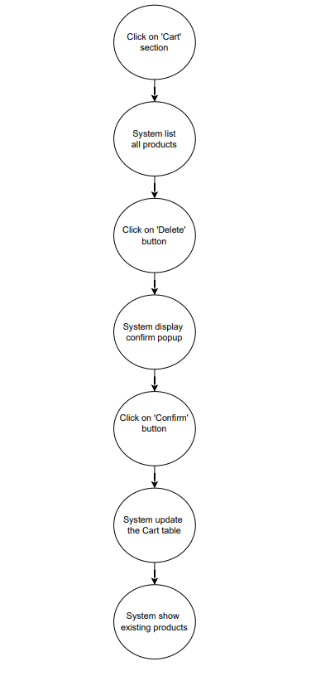

Alternative Flows

System does not have any product

If the buyer navigates to the Cart page and no products are available, the system displays an empty state message and ends the use case.

Seller cancels deleting a product

When the system displays a confirmation dialog box, the buyer may choose to click the "Cancel" button to abort the deletion process. The system closes the dialog box, and the use case ends without any changes to the products.

Special Requirements
There is no special requirement.

Preconditions
- There is at least one product that seller can delete in the system.

Postconditions
The selected product is deleted successfully from the system and the remaining products are displayed on the screen.

Extension Points
There is no extension point.

Prototype
- Buyers navigate to the "Cart" section, where the system automatically retrieves and lists all products from the database.

- Then, he/she select a product and click on the "Bin" icon to initiate the deletion process.
